[一]程序
#include<stdio.h>
int main()
{
printf("Hello World!");
printf("\n");
}

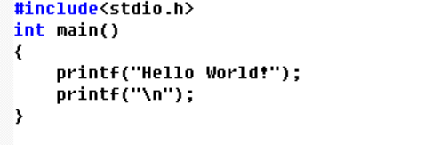
[二]运行结果

